**AMERPSOFT – Financial Plugin**

Name: org.amerpsoft.com.idempiere.financial

Pack: AMERPSOFT Financial.zip

CSV: AMERPSOFT Financial.csv

(For Import PACKOUT on a New Developing Data Base)

1. **AMERP Consultation.**

Application Dictionary Windows, for Consulting Accounts, Balances and Detail.

1. **Functions.**

Special Function for calculating Balances and Dates:

amf_acctdate0prevbalance.sql

amf_acctdate1deb.sql

amf_acctdate2cre.sql

amf_acctdate3balance.sql

amf_acctdate4currentbalance.sql

amf_acctper0prevbalance.sql

amf_acctper1deb.sql

amf_acctper2cre.sql

amf_acctper3balance.sql

amf_acctper4currentbalance.sql

amf_dow2letter.sql

amf_fiscalstartdate.sql

amf_month2letter.sql

amf_nextperiodenddate.sql

amf_nextperiodstartdate.sql

amf_num2letter.sql

amf_num2letter1000.sql

amf_periodenddate.sql

amf_periodstartdate.sql

amf_prevperiodenddate.sql

amf_prevperiodstartdate.sql

1. **Amf_Views:**

Must be created in order, because Views are dependant bethween them.

1. amf_accounts_v.sql

2. amf_accounts_detail_v.sql

3. amf_accounts_balance_v.sql

1. **Report Modules: AMERP Reports.**

Jasper Reports Financial Standard Formats.

Menu: 🡪 Amerpsoft Windows Financial Consultations

🡪 Amerpsoft Financial Reports

🡪 Bank Reports

1. **Processes.**

Menu: 🡪 Amerpsoft Processes

**PROCEDURES INCLUDED:**

1. **Dual Account Schema Setup**
2. **Currency Conversion Rate Copy**
3. **GL Journal Annual Closing**
4. **Repost Accounting**
5. **Multiple Account Schema Setup**

Multiple Account Schema is an available feature the Idempiere handles.  
That means that you can have multiple accounting set of accounts also with multiple currencies.

When using same account elements for all Accounting Schemas and different currencies you may have Accounting facts and results on different currencies.

That is the case where this plugin procedure may help.

(SAME Account Elements with different currencies)

Account Schema Window, which shows Table C_AcctSchema table, has three related Tabs for tables:

**C_AcctSchema_Element:** Defined Dimensions for Client

**C_AcctSchema_GL:** GL Default accounts for Client

**C_AcctSchema_Default:** Standard Default accounts for Client

If you create a new Account Schema, you must fill all records and account combinations.

Account combination table contains important information for Fact Acct, one of this particular field is C_AcctSchema_ID, which refers to Account Schema.

Before filling all default accounts on Account Schema Window we must define all account combinations.

On the other hand, all Accounting Parameterization defined on tables:

|  |  |  |
| --- | --- | --- |
| **Bank and others** | **Material** | **Business Partners** |
| C_Charge_Acct | M_Product_Acct | C_BP_Group_Acct |
| C_BankAccount_Acct | M_Product_Category_Acct | C_BP_Customer_Acct |
| A_Asset_Actt | M_Warehouse_Acct | C_BP_Vendor_Acct |
| A_Asset_Group_Acct |  | C_BP_Employee_Acct |
| C_Project_Acct |  |  |
| C_Charge_Acct |  |  |

These tables must have new records for the new Account Schema.

Available procedure can double valid combinations, Account schema tabs, Material tables, Business Partners tables and Bank Accounting. As you select on procedure parameters.

***NOTE: Before running this procedure, you must create first the Account Schema and reset Idempiere Server.***

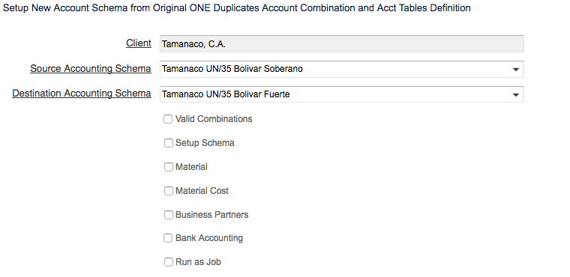

**Sample Results:**

**Account Schema Window:**

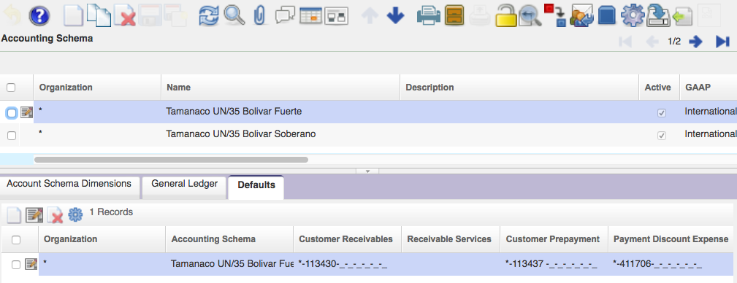

**Business Partner Groups:**

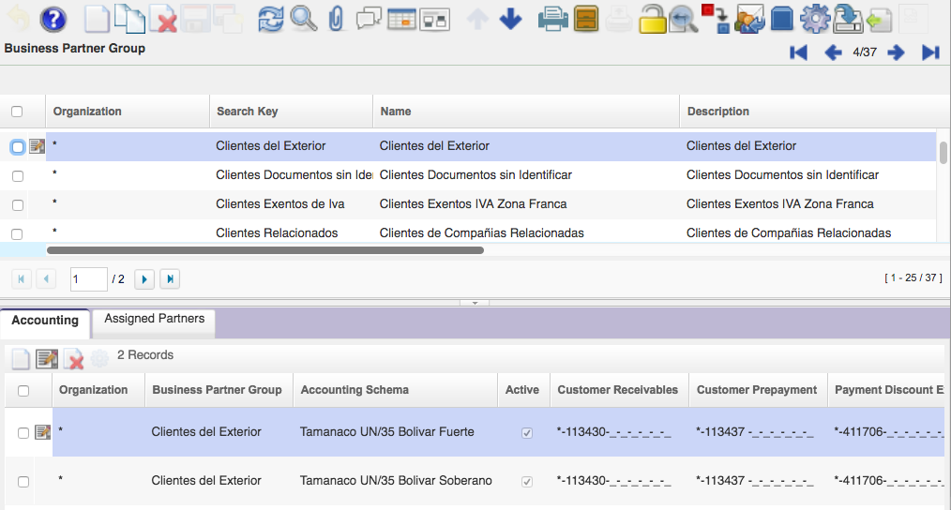

1. **Currency Conversion Rate Copy**

This procedure applies when have a monetary reconversion, like the one happened in Venezuela.

In this particular there are two currencies with fixed conversion rate. An User must define other currencies conversions. The this procedure just copy then with the fixed currency reconversion rate.

This only apply on Money reconversion case.

1. **GL Journal Annual Closing**

This procedure Generates GL Annual closing journal entries fro a given Finish period.

Default Accounts already defined on Account Schema Window are used to carry on this process.

**See Accounting Schema Window (GL Default TAB):**

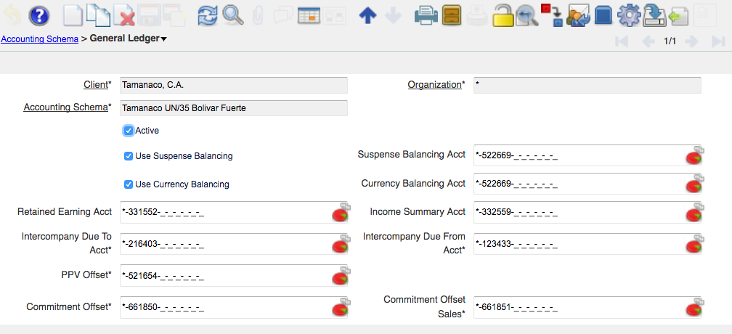

Retained earnings Acct is used to summarize Income and expense accounts.

Procedure ask you for Client, Organization, Accounting Schema, Period and result account.

It will generate a GL Journal to close Period.

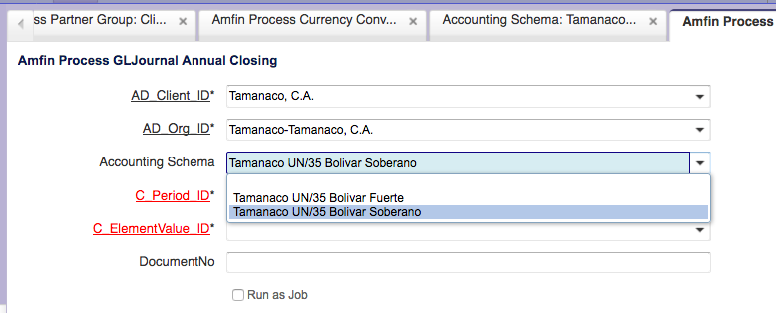

1. **Repost Accounting**

Repost Accounting is very useful, when you make changes on accounting parameterization and you want to make lot reposting on documents.

Idempiere provides the possibility to Re-Post a document in the Accounting facts window as you can se on the following figure for a Invoice Facts:

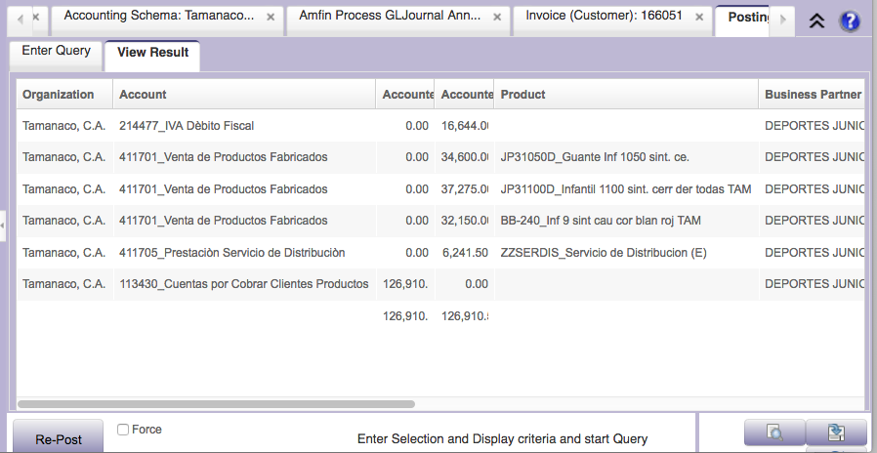

Re-Post button allows you to make a new set of accounting lines depending on changes made to Business Partner of Products.

Using Financial Plugin procedure you may Re-Post document lots on one period.

See Parameter Window:

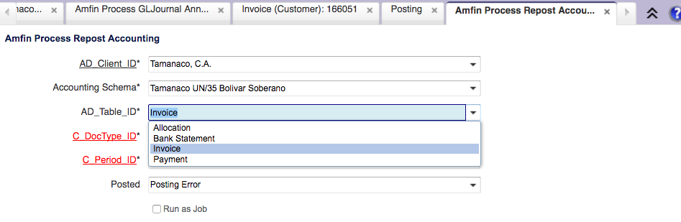

You may select Table involved on accounting document, document type associated an period.